第三章：商品品名数量包装及价格
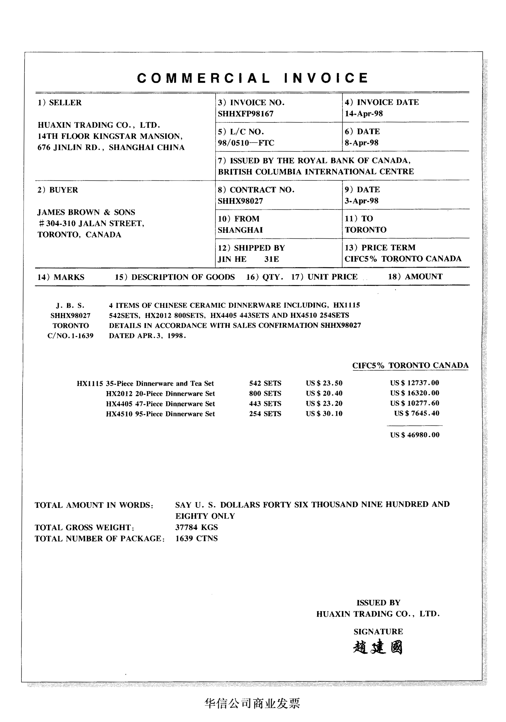

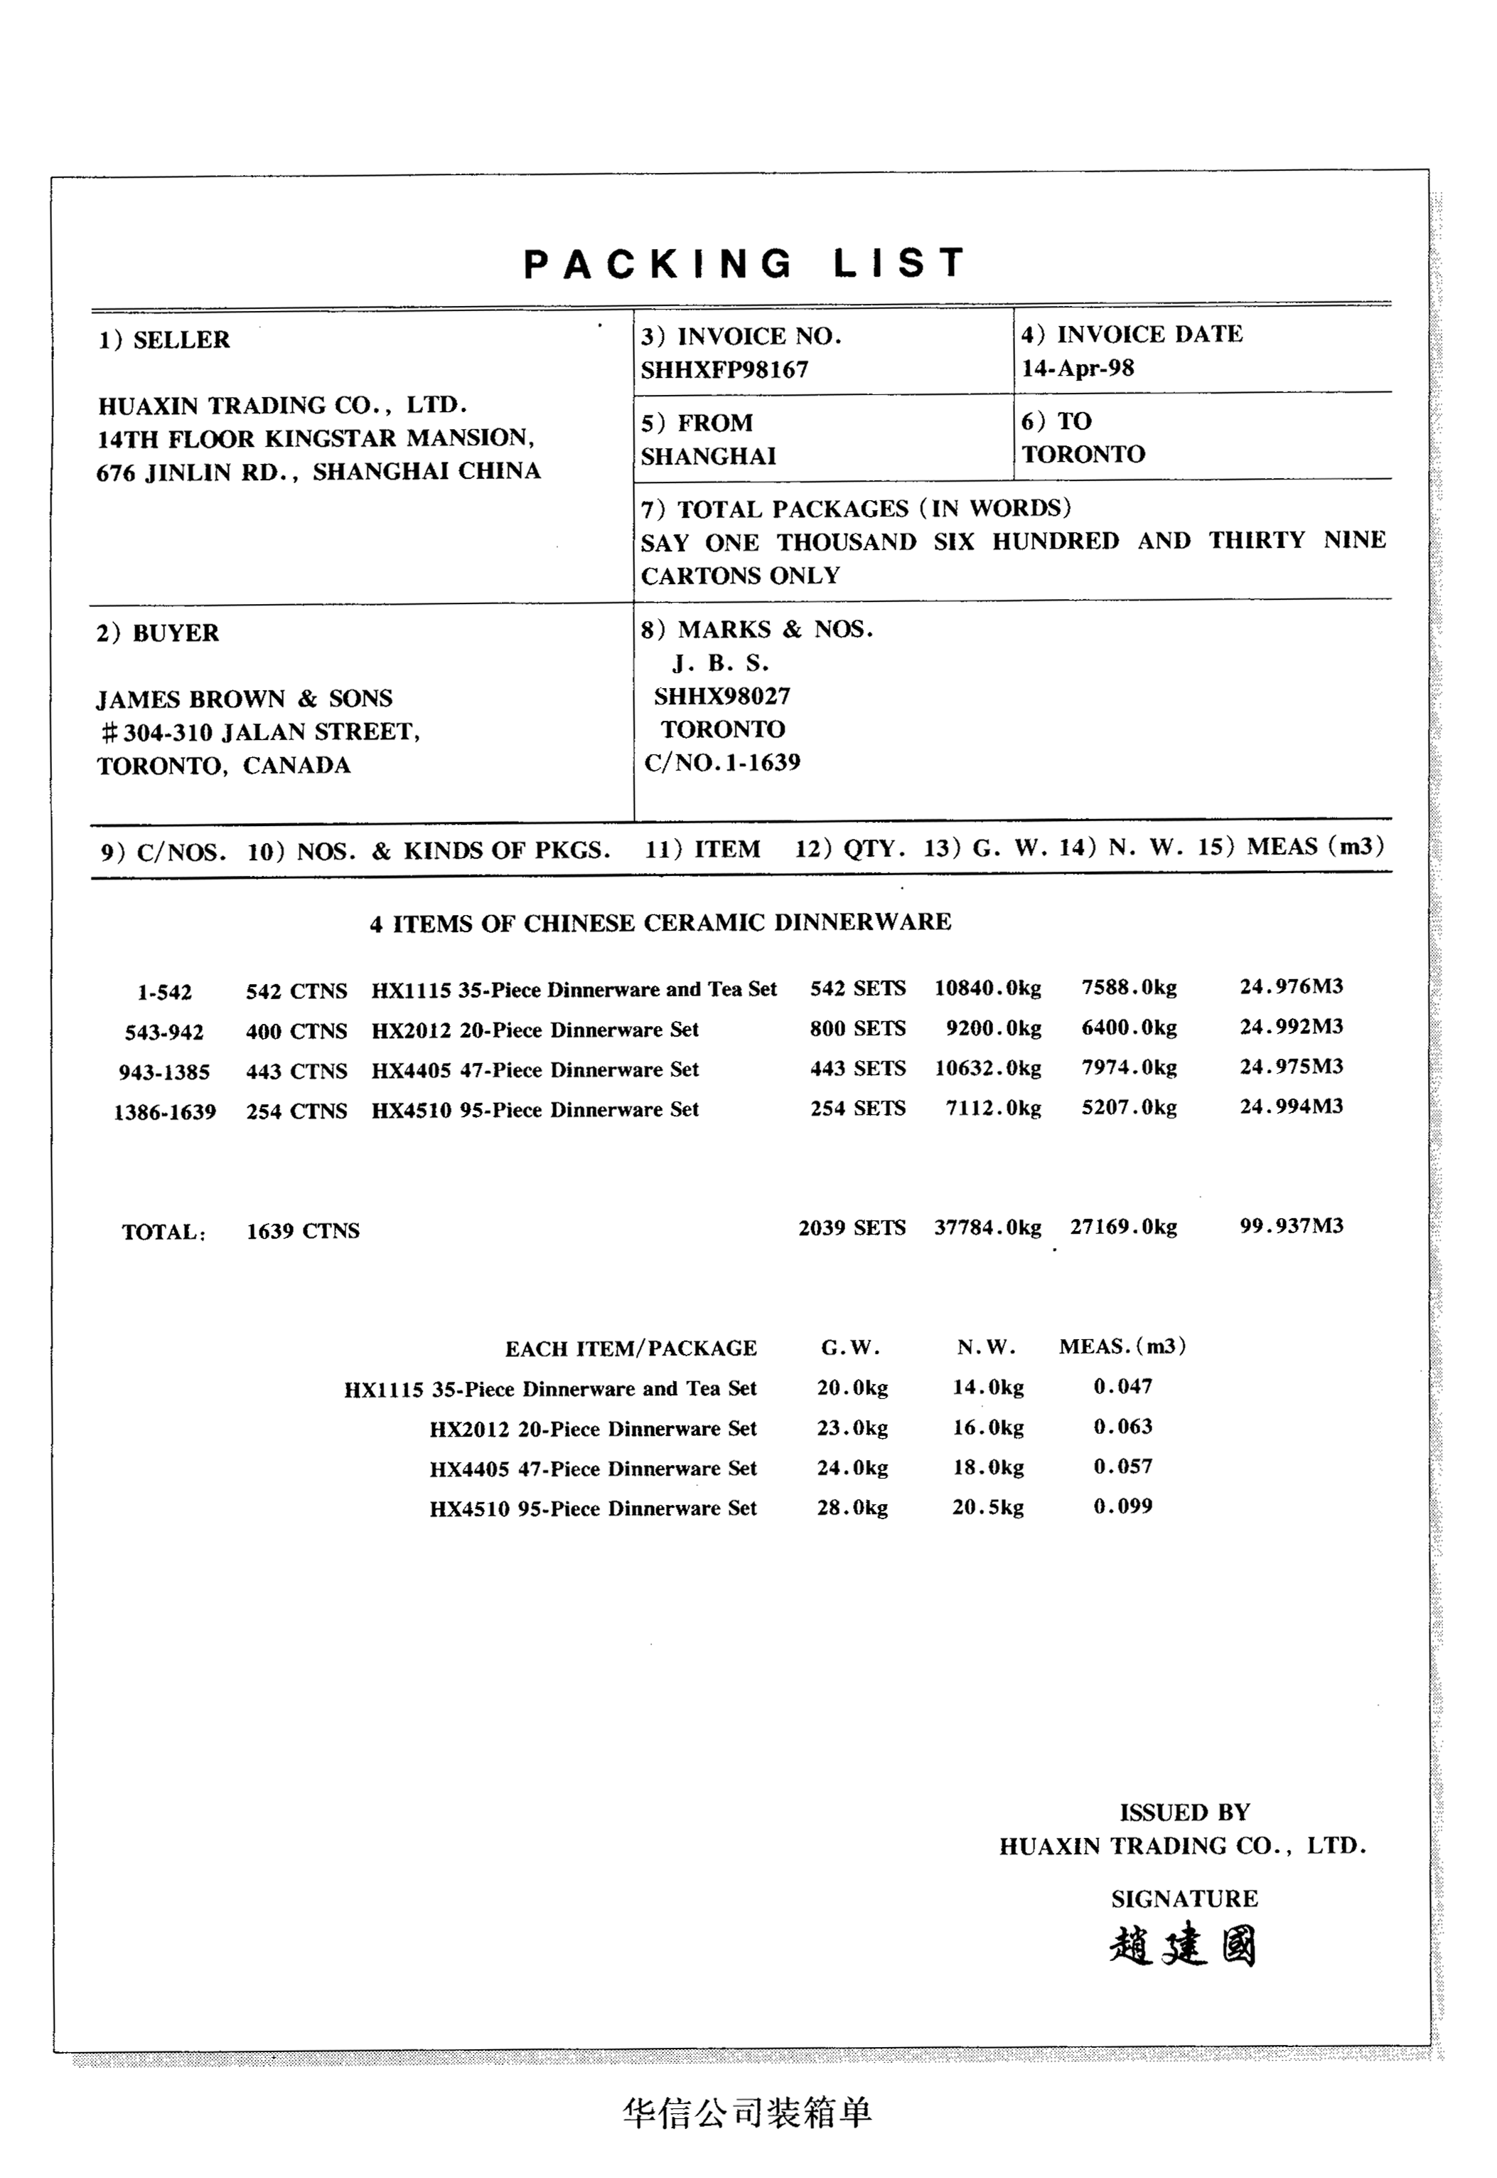
货物明细 商品名称：Trolley Cases
货号
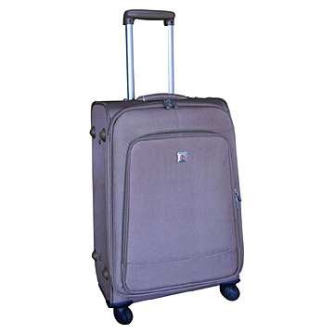
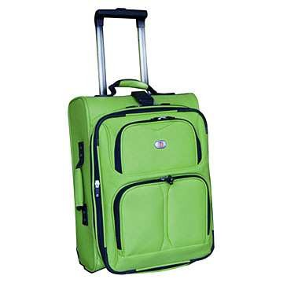
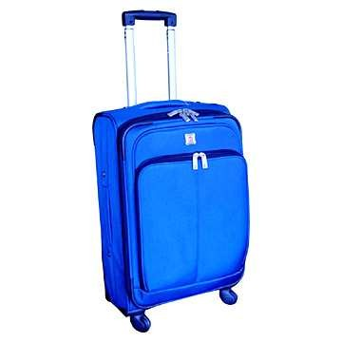
TS503214 TS503215 TS503216
产地 Dalian China
商标 TAISHAN
包装 1 pc in 1 PE bag;3pcs/CTN
箱子尺寸 53.5 × 37 × 79.5cm 53.5 × 34.5 × 82cm 48 × 32.5 × 78.5cm
0.1573cbm 0.151cbm 0.1225cbm
箱子尺寸（总） 57.8864cbm 57.833cbm 58.8cbm
净重/毛重（个） 4 KG/ 4.6KG 3.5 KG/ 4KG 3KG/ 3.5KG
净重/毛重（总） 4416KG/5078.4 KG 4021.5KG/ 4596KG 4320KG/ 5040KG
数量 1104PCS 1149PCS 1440PCS
单价 USD6.50 USD6.00 USD5.80
金额 USD7176 USD6894 USD8352
集装箱容量 Qty/40' FCL: 368ctns Qty/40' FCL: 383ctns Qty/40' FCL: 480ctns
发票号码：TSI0801005 发票日期：2008-8-5 授权签字人：张平
装运船名：DONGFENG 航 次：V.369 装船日期：2008-8-23
运输标志： ORTAI
TSI0601005
NEW YORK
C/NO.1-1231
原产地标准：“P”

2．信用证相关内容
27: Sequence of Total：1/1
40A: Form of Documentary Credit：IRREVOCABLE
20: Documentary Credit Number：N5632405TH11808
31C: Date of Issue：080715
31D: Date and Place of Expiry：080909 CHINA
51D: Applicant Bank：CITY NATIONAL BANK
133 MORNINGSIDE AVE NEW YORK, NY 10027 Tel:001-212-865-4763
50: Applicant：ORTAI CO., LTD.
30 EAST 40TH STREET, NEW YORK, NY 10016
TEL:001-212- 992-9788 FAX: 001-212- 992-9789
59: Beneficiary：DALIAN TAISHAN SUITCASE & BAG CO., LTD.
66 ZHONGSHAN ROAD DALIAN 116001, CHINA TEL:0086-0411-84524789
32B: Currency Code Amount：USD 22422.00
41D: Available With/By：ANY BANK IN CHINA BY NEGOTIATION
42C: Drafts at：SIGHT
42D: Drawee：ISSUING BANK
43P: Partial Shipments：NOT ALLOWED
43T: Transshipment：NOT ALLOWED
44E: Port Of Loading：DALIAN,CHINA
44F: Port Of Discharge：NEW YORK,U.S.A
44C: Latest Date of Shipment：080825
45A: Description of Goods and/or Services：CIF NEWYORK TROLLEY CASES AS PER SC NO. TSSC0801005
46A: Documents Required
+MANUALLY SIGNED COMMERCIAL INVOICE IN 2 COPYES INDICATING L/C NO. AND CONTRACT NO. CERTIFYING THE CONTENTS IN THIS INVOICE ARE TRUE AND CORRECT.
+FULL SET OF ORIGINAL CLEAN ON BOARD MARINE BILLS OF LADING MADE OUT TO ORDER, ENDORSED IN BANK MARKED FREIGHT PREPAID AND NOYIFY APPLICANT
+PACKING LIST IN 2 COPYES ISSUED BY THE BENEFICIARY
+ORIGINAL GSP FORM A CERTIFICATE OF ORIGIN ON OFFICIAL FORM ISSUED BY A TRADE AUTHORITY OR GOVERNMENT BODY
+INSURANCE POLICIES OR CERTIFICATES IN DUPLICATE, ENDORSED IN BLANK FOR 110 PERCENT OF INVOICE VALUE COVERING ICC CLAUSES(A)
+MANUFACTURER’S QUALITY CERTIFICATE CERTIFYING THE COMMODITY IS IN GOOD ORDER
+BENEFICIARY’S CERTIFICATE CERTIFYING THAT ONE SET OF COPIES OF SHIPPING DOCUMENTS HAS BEEN SENT TO APPLICANT WHTHIN 5 DAYS AFTER SHIPMENT
47A: Additional Conditions
+UNLESS OTHERWISE EXPRESSLY STATED, ALL DOCUMENTS MUST BE IN ENGLISH
+ANY PROCEEDS OF PRESENTATIONS UNDER THIS DC WILL BE SETTLED BY TELETRANSMISSION AND A CHARGE OF USD50.00 (OR CURRENCY EQUIVALENT) WILL BE DEDUCTED
49: Confirmation Instructions：WITHOUT
57D: Advise Through Bank：BANK OF CHINA DALIAN BRANCH
72: Sender to Receiver Information：DOCUMENTS TO BE DESPATCHED BY COURIER SERVICE IN ONE LOT TO CITY NATIONAL BANK

Issuer |  |  | 商 业 发 票  COMMERCIAL INVOICE
TO |  |  | Invoice No. |  | Date
Transport Details |  |  | S/C NO. |  | L/C NO.
Marks and  Numbers | Description of Goods | Quantity |  | Unit Price |  | Amount
 |  | ----------- |  |  |  | -------------
TOTAL PACKAGES IN WORDS:____________________________________________________

WE HEREBY CERTIFY THAT THE CONTENTS IN THIS INVOICE ARE TRUE AND CORRECT.
DALIAN TAISHAN SUITCASE & BAG CO., LTD.
张平

Issuer |  |  |  | 装 箱 单  PACKING LIST
TO |  |  |  | Invoice No. |  |  | Date
 |  |  |  | S/C NO. |  |  | L/C NO.
Marks and  Numbers | C/NOS. | Number and Kind of Packages; Description of Goods | Quantity |  | G.W. (KGS) | N.W. (KGS) |  | MEAS. (CBM)
Total
TOTAL PACKAGES IN WORDS:______________________________________________________

DALIAN TAISHAN SUITCASE & BAG CO., LTD.
张平

